CS570 Project Report
4) Summarize the Attributes of the Data
1) Data Types and Format
This project used two datasets for two different machine learning tasks. Part 1 used the provided project dataset for traditional machine learning classification, while Part 2 used the load_digits dataset from scikit-learn for neural network classification. The datasets have different structures and characteristics, which influenced the preprocessing and modeling techniques used in each part.
The Part 1 dataset contains 1,728 observations and seven columns. Six columns, feat1 through feat6, are predictor variables, while class is the target variable. The original dataset contains categorical values rather than continuous numerical measurements. The predictor variables include categories such as low, med, high, vhigh, small, big, 2, 3, 4, and 5more. The target variable contains four classes: unacc, acc, good, and vgood. The initial data exploration showed that the dataset contained no missing values and no duplicate records. The target classes were not evenly distributed. The unacc class contained 1,210 observations (70.02%), acc contained 384 observations (22.22%), good contained 69 observations (3.99%), and vgood contained 65 observations (3.76%). This class distribution was considered when evaluating the models because accuracy alone may not fully describe classification performance when the target classes are imbalanced. Therefore, accuracy, precision, recall, F1-score, confusion matrix, and Cohen's kappa were evaluated as required by the project.
The Part 2 dataset uses scikit-learn's load_digits dataset, as specified in the project requirements. It contains 1,797 observations and 64 numerical pixel features. The 64 features represent the pixels of 8 × 8 handwritten digit images. Pixel values range from 0 to 16, and the target variable contains ten classes representing the digits 0 through 9. The classes are relatively balanced, with individual class frequencies ranging from approximately 174 to 183 observations. The dataset also contained no missing values and no duplicate records.
The two datasets therefore required different preprocessing approaches. Part 1 began with categorical predictor variables that needed to be converted into numerical representations before modeling, whereas Part 2 already contained numerical pixel features and primarily required feature scaling before neural network training. The project explicitly requires load_digits and an MLPClassifier for Part2.
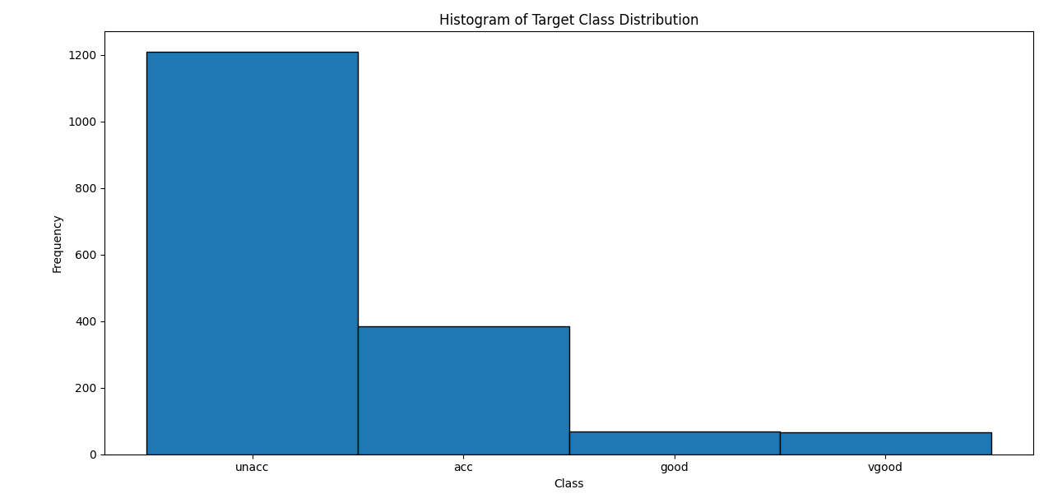Figure1. Histogram of Target Class Distribution
The histogram demonstrates the substantial imbalance between the four target classes, particularly the much larger number of unacc observations compared with good and vgood.
5) Data Categorization during Preprocessing
The Part 1 dataset contains categorical predictor variables, so the categories had to be converted into numerical representations before they could be used by the machine learning models. Because several of the variables have a meaningful natural order, ordinal encoding was selected rather than assigning arbitrary category labels.
For feat1 and feat2, the categories were ordered from low to med, high, and vhigh. For feat3, the categories were ordered as 2, 3, 4, and 5more. For feat4, the categories were represented as 2, 4, and more. Similarly, feat5 was categorized as small, med, and big, while feat6 was categorized as low, med, and high. This approach preserves the meaningful ordering represented by the original categorical values. For example, low, med, high, and vhigh represent increasing levels of the same characteristic, so treating them as ordered categories provides the model with a numerical representation that reflects the structure of the original data.
The target variable, class, contains four categories: unacc, acc, good, and vgood. These categories were treated as classification labels rather than continuous numerical measurements. An ordinal representation of the target was used separately for the exploratory correlation analysis, allowing correlations to be visualized numerically. This encoding was used only for exploration and was not interpreted as a causal relationship or feature importance. The ordinal encoder was configured with the specific category order and was included within the preprocessing pipeline used for model evaluation. This ensured that the same categorization procedure was consistently applied to the training and testing data while also allowing the pipeline to handle previously unseen categories safely.
Overall, categorizing the variables according to their natural ordering provided an appropriate numerical representation of the categorical dataset while preserving information contained in the original category labels.
6) Describe the Data Transforming Processes used for Preprocessing
The data transformation process for Part 1 was designed to convert the categorical input variables into a numerical format that could be processed by the machine learning algorithms. First, the target variable, class, was separated from the six predictor variables. The dataset was then divided into 80% training data and 20% testing data using a stratified split. Stratification was selected because the target classes were imbalanced, so maintaining similar class proportions in the training and testing sets was important for reliable evaluation.
The six categorical predictor variables were transformed using OrdinalEncoder. Because the variables have meaningful ordered categories, explicit category ordering was provided. For example, low < med < high < vhigh was used for feat1 and feat2, while small < med < big was used for feat5. The encoder was fitted only on the training data and then used to transform the testing data. This approach prevents information from the testing set from influencing the preprocessing process. After encoding, StandardScaler was applied to the numerical features. Standardization placed the transformed variables on a comparable scale, which was particularly important for k-nearest neighbors (kNN) because kNN relies on distances between observations. The scaler was fitted using only the training data and then applied to the testing data. The final model evaluation also used preprocessing pipelines that combined encoding and standardization, helping maintain consistent preprocessing during cross-validation.
No missing-value imputation or duplicate-record removal was necessary because the dataset contained no missing values or duplicate records. Overall, these transformations were chosen to make the categorical data numerically usable, preserve the natural ordering of the predictor categories, maintain class proportions, and provide appropriately scaled inputs for the selected distance-based model.
7) Explain the Algorithm and Data Characteristics Used to Decide How to Preprocess the Data
1) How did the algorithm type inform the preprocessing techniques?
The selected k-nearest neighbors (kNN) algorithm strongly influenced the preprocessing approach because kNN makes predictions based on the distance between observations. The original dataset contained categorical values, so the features first needed to be converted into numerical values. OrdinalEncoder was selected because the categorical variables have meaningful natural ordering, such as low < med < high < vhigh. After encoding, StandardScaler was applied so that the features were placed on comparable scales. This was important for kNN because differences in feature scales can affect distance calculations and consequently influence the model's predictions (scikit-learn developers, n.d.-a).
2) What data characteristics did you consider for preprocessing?
Several characteristics of the dataset were considered. The six predictor variables were categorical and contained ordered levels, which supported the use of ordinal encoding. The target variable contained four classes: unacc, acc, good, and vgood, with an uneven class distribution. Because of this imbalance, a stratified 80/20 train-test split was used to preserve approximately the same class proportions in both datasets. The dataset also contained no missing values and no duplicate records, so missing-value imputation and duplicate removal were not required.
3) How did other factors such as algorithmic constraints affect preprocessing?
The main algorithmic constraint was that kNN requires numerical feature values and is sensitive to feature scale because it uses distance calculations. Therefore, categorical values could not be provided directly to the model and had to be encoded and standardized first. Another important consideration was avoiding data leakage. The encoder and scaler were fitted using the training data and then used to transform the testing data. The same transformations were incorporated into a preprocessing pipeline during cross-validation, ensuring that information from the evaluation data was not used to train the preprocessing steps (scikit-learn developers, n.d.-b).
8) Describe the Strengths and Weaknesses of the Selected Machine Learning Algorithm
The selected algorithm was k-nearest neighbors (kNN). It performed better than the other tested models, achieving 94.86% baseline cross-validation accuracy. After optimization, the model achieved 97.40% test accuracy, 97.36% F1-score, and 94.29% Cohen's Kappa, showing that it was highly effective for this dataset.
Strengths
A major strength of kNN is its high predictive performance on this dataset. It is also relatively simple to implement and can make predictions based on similarities between observations. Hyperparameter tuning further improved its performance by selecting 11 neighbors, distance weighting, and the Manhattan distance metric.
Weaknesses
kNN is sensitive to feature representation and scaling because it relies on distance calculations. It can also require more computation when making predictions on larger datasets. In addition, its performance depends on selecting suitable values for parameters such as the number of neighbors and distance metric. These limitations were addressed through ordinal encoding, standardization, cross-validation, and GridSearchCV.
9) Explain the Training Methods Used for the Machine Learning Model
The k-nearest neighbors (kNN) model was trained using the preprocessed training dataset. The categorical features were converted into numerical values using ordinal encoding and then standardized. A 5-fold Stratified Cross-Validation method was used to evaluate model performance across multiple training and validation folds while maintaining the class proportions (scikit-learn developers, n.-d).
Three classification models kNN, Discriminant Analysis, and Gaussian Naive Bayes were compared using cross-validation. kNN achieved the highest mean cross-validation accuracy of 94.86% and was selected for further optimization. The selected kNN model was then trained using the complete training dataset and evaluated on the separate test dataset.
10) Describe the Steps Taken to Optimize the Model
a) Model Validation Method
The model was validated using 5-fold Stratified Cross-Validation. The training data was divided into five folds while maintaining the class proportions in each fold. The baseline kNN model achieved a mean cross-validation accuracy of 94.86%. Cross-validation was used to obtain a more reliable estimate of model performance before selecting and optimizing the final model.
b) Tuning Techniques
The kNN model was optimized using GridSearchCV. A total of 36 parameter combinations were evaluated using the same 5-fold cross-validation procedure. Three hyperparameters were tuned: number of neighbors (3, 5, 7, 9, 11, and 15), weighting method (uniform or distance), and distance metric (Euclidean, Manhattan, or Minkowski). The best configuration was 11 neighbors, distance weighting, and Manhattan distance, with a cross-validation accuracy of 95.30%. The optimized model was then evaluated on the separate test set and achieved 97.40% accuracy.
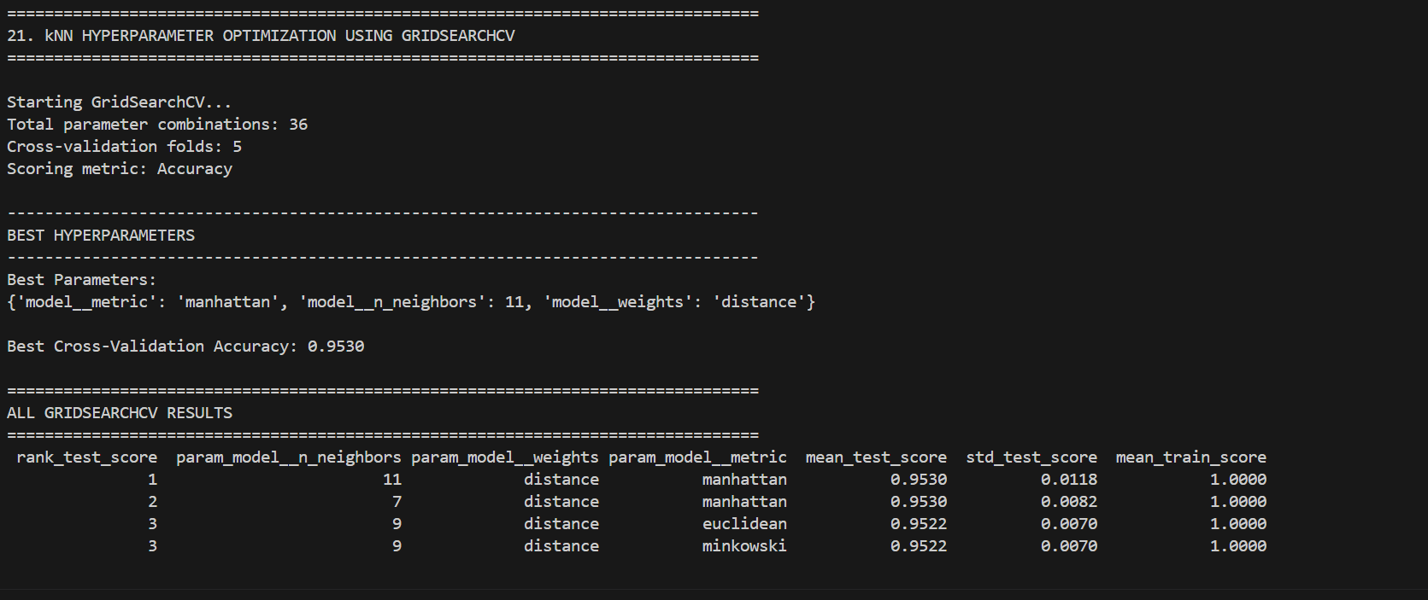Figure2. GridSearchCV Results for kNN Hyperparameter Optimization
11) Summarize Your Modeling Recommendations for the Given Data Set and Prediction Requirements
a) What other modeling options could you recommend?
Other classification algorithms could also be considered for this dataset, including Discriminant Analysis, Naive Bayes, decision trees, and ensemble methods. These models may provide alternative approaches for handling categorical classification problems and could be evaluated if additional modeling comparisons were required.
b) Why is the selected algorithm most appropriate?
k-nearest neighbors (kNN) was selected because it produced the strongest results among the models tested in this project. Its baseline cross-validation accuracy was 94.86%, higher than Discriminant Analysis (80.82%) and Naive Bayes (70.04%). After GridSearchCV optimization, the best configuration used 11 neighbors, distance weighting, and Manhattan distance, and achieved 97.40% test accuracy and 97.36% F1-score. Based on these experimental results, kNN was the most appropriate algorithm for the dataset and its classification requirements.
12) Explain the Neural Network Training and Validation Split
The Part 2 digits dataset was divided into training and validation sets using an 80/20 stratified split. The training set contained 1,437 observations, while the validation set contained 360 observations, with all 64 pixel features retained. Stratification was used to maintain a similar distribution of the ten digit classes in both sets.
The training data was used to train the MLPClassifier, while the validation data was kept separate for evaluating the model's performance on previously unseen observations. Before training, StandardScaler was fitted on the training data and then applied to both the training and validation sets. This resulted in appropriately scaled input features for the neural network.
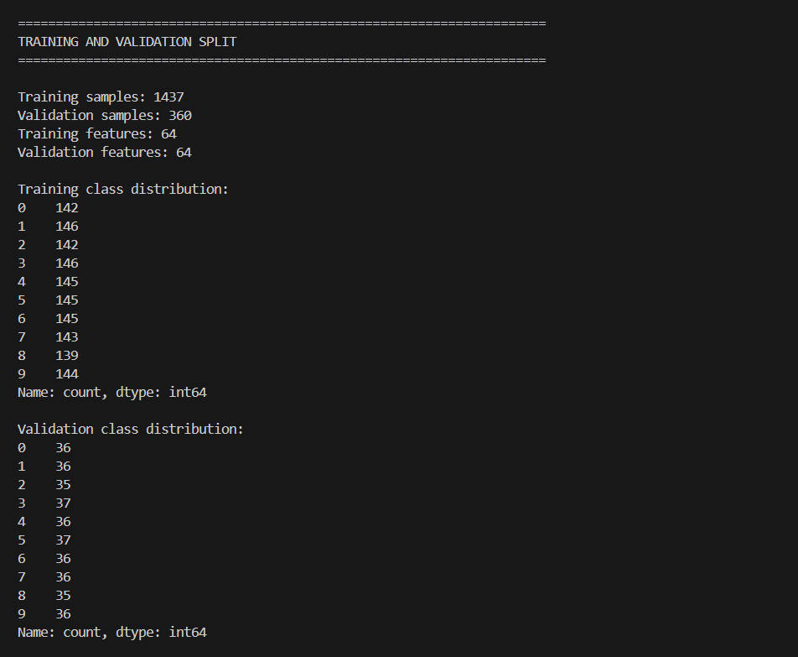
Figure3. Training and Validation Split for the Neural Network
13) Identify the Training Algorithm(s) Used for the Neural Network
a) Why did you choose this algorithm?
The neural network was trained using the Adam optimization algorithm through the MLPClassifier. Adam was selected because it is an effective optimization method for training neural networks and automatically adapts the learning rate during training. It was appropriate for the handwritten-digit classification task because the dataset contains 64 numerical pixel features and multiple digit classes. The selected MLP used ReLU activation, Adam solver, a batch size of 32, and a maximum of 300 iterations.
The model trained successfully and required only 68 iterations to converge, producing a final loss of approximately 0.001794. Therefore, Adam provided an effective training approach for the neural network in this project.
14) Describe the Training Methods Used for the Neural Network
a) Did you use manual and/or algorithmic training? Explain why.
The neural network used algorithmic training rather than manually adjusting the model parameters. The MLPClassifier used the Adam solver to automatically optimize the network during training. Algorithmic training was chosen because it efficiently adjusts the model's internal parameters based on the training data and loss function.
b) What were the initial hyperparameters you defined?
The initial MLP configuration used:
Hidden layer: (100,)
Activation: ReLU
Solver: Adam
Learning rate: Constant
Maximum iterations: 300
Batch size: 32
Random state: 42
These parameters were defined before training the baseline neural network.
c) How did you adapt the hyperparameters to improve the network?
The hyperparameters were adapted using GridSearchCV with 5-fold cross-validation. The search evaluated different hidden-layer sizes (50,) and (100,), activation functions (ReLU and tanh), solvers (Adam and SGD), learning-rate strategies (constant and adaptive), maximum iterations (300 and 500), and batch size (32). In total, 32 combinations were evaluated. The GridSearchCV results selected the original configuration 100 hidden units, ReLU, Adam, constant learning rate, 300 maximum iterations, and batch size 32 with a best cross-validation accuracy of 97.63%. Therefore, the optimization confirmed that the initial configuration was already the best among the tested combinations rather than requiring a change.
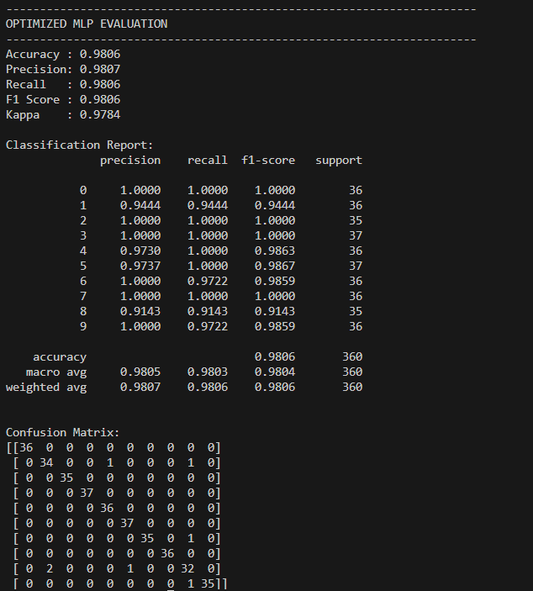
Figure4: Optimized MLP Evaluation Results and Confusion Matrix
Conclusion
The project demonstrated the application of machine learning techniques to two classification problems. In Part 1, several classification algorithms were compared, and k-Nearest Neighbors (kNN) achieved the strongest cross-validation performance. Hyperparameter tuning using GridSearchCV identified 11 neighbors, distance weighting, and the Manhattan distance metric as the best configuration. The optimized kNN achieved 97.40% accuracy, 97.36% F1-score, and 94.29% Kappa on the test dataset.
In Part 2, the load_digits dataset was analysed and classified using an MLP neural network. The data was standardized and evaluated using stratified validation and GridSearchCV. The selected MLP configuration achieved 98.06% accuracy, 98.06% F1-score, and 97.84% Kappa on the validation dataset. Overall, the project demonstrated the importance of appropriate preprocessing, model comparison, cross-validation, hyperparameter tuning, and multiple evaluation metrics when developing reliable machine learning models.
References
Scikit-learn developers. (n.d.-a). GridSearchCV. https://scikit-learn.org/stable/modules/generated/sklearn.model_selection.GridSearchCV.html
Scikit-learn developers. (n.d.-b). KNeighborsClassifier. https://scikit-learn.org/stable/modules/generated/sklearn.neighbors.KNeighborsClassifier.html
Scikit-learn developers. (n.d.-c). MLPClassifier. https://scikit-learn.org/stable/modules/generated/sklearn.neural_network.MLPClassifier.html
Scikit-learn developers. (n.d.-d). OrdinalEncoder. https://scikit-learn.org/stable/modules/generated/sklearn.preprocessing.OrdinalEncoder.html
Scikit-learn developers. (n.d.-e). StandardScaler. https://scikit-learn.org/stable/modules/generated/sklearn.preprocessing.StandardScaler.html

